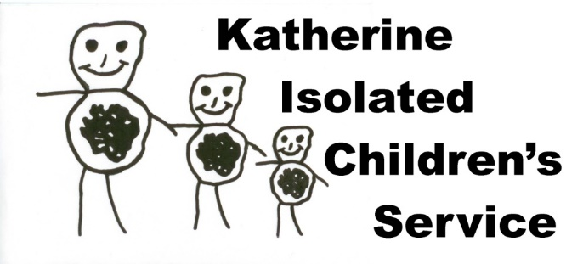
Position Vacant
Field Team 1
Fixed Term Contract

Thank you for your interest in the position of Field Team 1 (2 people).

KICS is a remote mobile Playgroup and Parent information service. We operate in the NT in an area of approx. 750 000sq km. Our Field Teams provide educational, play-based Playgroups for socially and geographically isolated children. We service Indigenous communities, cattle stations, small townships and invitational events such as campdrafts and Playgroup in the Park events.

Our client group are children aged from birth to 12 years old and their parents & families, carers and educators. The focus age group are children aged between birth and 5 years old, but some older ‘School of the Air’ children may join in. In addition to Playgroups we provide parents with information, resources and support regarding the education and development of their children.

The families we work with are beyond mainstream services. This position is not a traditional teaching or Early Childhood position; we operate in unique situations, with a distinctive style of service delivery. As such the Field Team position requires a team who are flexible, innovative and eager for a challenging and rewarding experience.

The position involves extensive driving on rough dirt roads to some of the most remote areas of the NT. The demands of the service delivery may necessitate some weekend work as well as sometimes having to work on public holidays; this is not the usual 9 to 5 position. Our staff operate on a time-in-lieu basis for additional hours worked beyond a normal working week; time-in-lieu accrued may be used during the year in negotiation with the Program Coordinator. Whilst we do not travel during the school holidays there is still some office work required at these times.

Due to the vehicle set-up and the style of this position it is suitable for a team (2 people) only.

Remuneration package will be in the region of $45,000 annual salary per person pro rata. For each night you camp in the field you will receive $104 tax free income, paid at the end of each term. There is also a tax zone rebate you would be entitled to when submitting your tax return.

The position of a KICS Field Team is demanding, challenging and constantly changing, however it is an exceptionally rewarding and satisfying opportunity that offers unforgettable experiences and a unique lifestyle. It offers a rare opportunity to visit some of the most remote and beautiful parts of the country. There is often enough time between Playgroup venues to enjoy the scenery, fishing, walking tracks etc with permission from the Traditional Owners or property managers.

The commencement date for the position will be 8am Tuesday 14th April 2019 and ends 2pm Friday 2nd October 2020.

If you have what it takes, then send your application to us by COB Friday 22nd November 2019 to coordinator@kics.org.au or PO Box 1601 Katherine NT 0851

Mandy Tootell
KICS Coordinator

Field Team 1
Fixed Term contract
Selection Criteria

Essential
- Early Childhood qualification and/or relevant experience working with young children (Playgroup Leader);
- NT ‘C’ class driver’s licence (both team members);
- An existing ‘Ochre Card’ and ‘National Police Check’ or application in process (both team members).
- Demonstrated ability to work effectively with children and adults;
- Demonstrated ability to interact with people of diverse cultures;
- Demonstrated ability and experience of driving and working in remote regions;
- Basic mechanical skills and knowledge.

Highly Desirable
- Demonstrated decision making abilities of a high order including the ability to work both independently and as a team member;
- Demonstrated ability to exercise initiative and be flexible in ever changing work situations;
- Demonstrated experience driving with a trailer;
- Demonstrated ability to live/camp in remote locations;
- Demonstrated off road driving experience.

Desirable
- Demonstrated ability to work and communicate with a range of people including station workers, Indigenous people, Government and non-government employees;
- Senior First Aid Certificate (both team members);
- Moderate level of computer abilities/aptitude;
- Experience conducting presentations to various groups.

Please note Selection Criteria are required as a team not individually (unless otherwise stated).
Applicants to write one cover letter with your full names, postal addresses and telephone numbers responding to the Selection Criteria. Please also both attach a current CV with 2 referees each.

